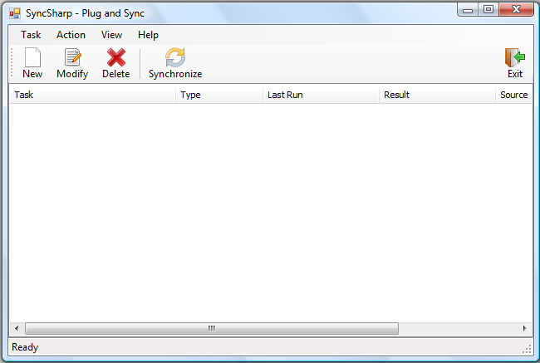
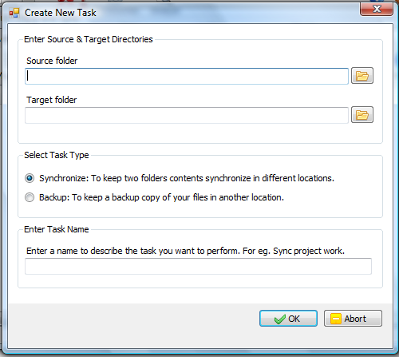
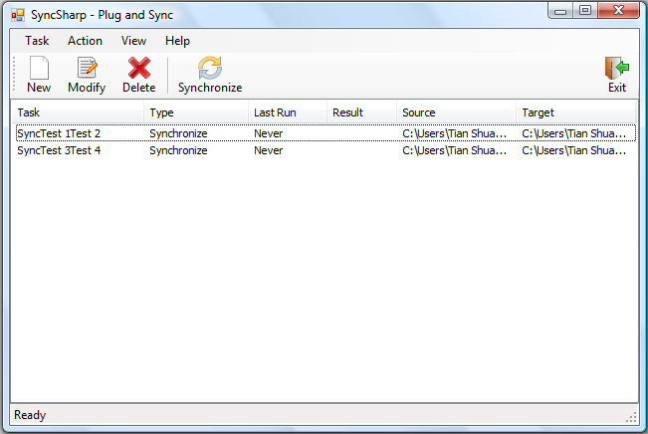
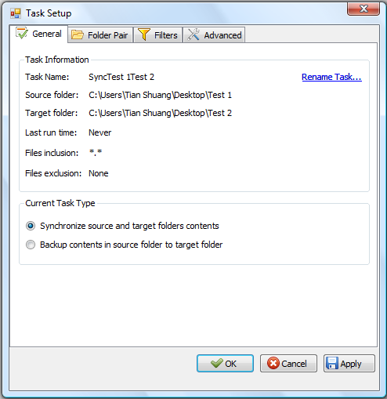
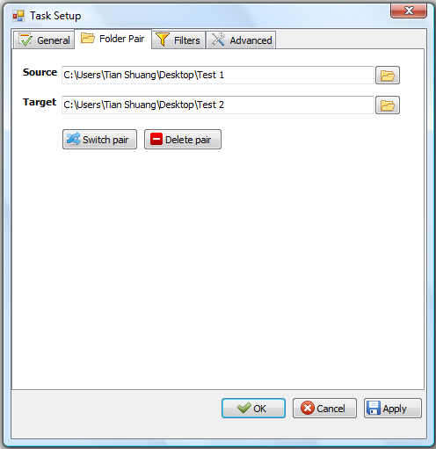
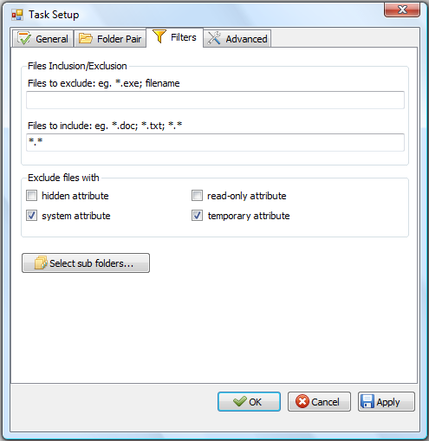
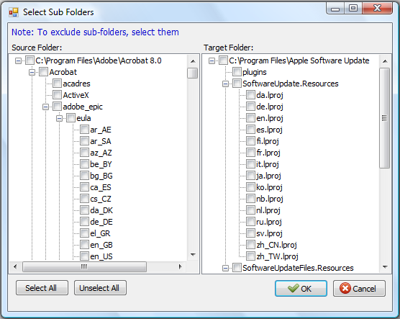
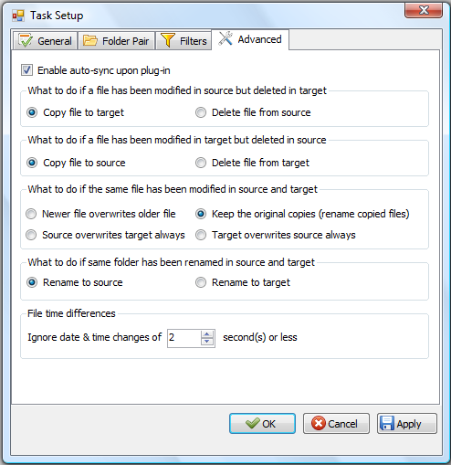
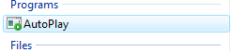
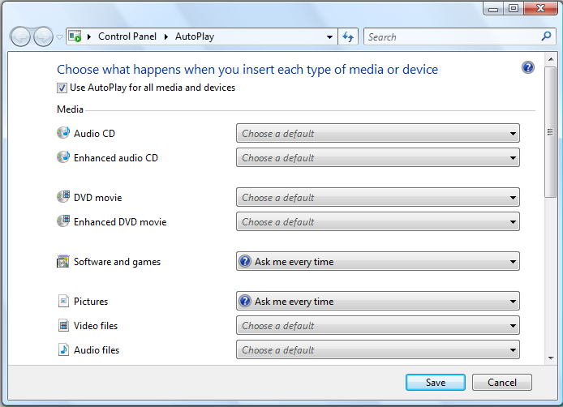
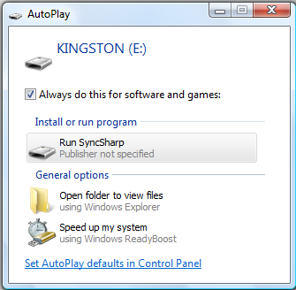
SyncSharp: Plug & Sync
File Synchronization Software

User Guide V0.9

3/18/2010

Azhar Bin Mohamed Yasin
Loh Jianxiong Christopher
Hong Lei
Guo Jiayuan
Tian Shuang
Tan Yewkang

TABLE OF CONTENTS

Chapter 1 User Guide

Part 1: Product Description 03

Part 2: Using SyncSharp
1.2.1 On First Run 03
1.2.2 Creating New Sync Task 04
1.2.3 Deleting New Sync Task 05
1.2.4 Modifying New Sync Task 05
1.2.5 Import Task 10
1.2.6 Export Task 11
1.2.7 PlugSync 11
Part 3: Troubleshooting
1.3.1 PlugSync Is Not Functioning Fully 11
Chapter 2 Glossary 13

Chapter 1 User Guide
Part 1: Product Description

Syncsharp is developed for users who work with multiple computers and need to synchronize files that reside in different computers through an immediate device such as a USB drive. It is a Windows based application that allows users to sync files between multiple computers through an immediate device with no installation required. The file synchronization process is streamlined through a list of pre-determined user preferences.

Part 2: Using Syncsharp

1.2.1 On First Run

On first run, user will need to activate SyncSharp by manually activate the program. Subsequently, the program will automatically run by itself. Upon double clicking the executable, the following main window will pop up.

1.2.2 Creating New Sync Task

Step 1: Click on New, the Create New Task window will show up.
Step 2: Click on the icon to locate the two folders (“Source folder” and “Target folder”) that you would like to synchronize.
Step 3: Select Task Type.
Synchronize – Synchronize source and target folders
Backup – Keep a copy of files in “Source folder” in “Target folder”.
Step 4: Enter Task Name. Specify the name of this Sync Task. (This task will be saved, so next time the program is activated. It will automatically try to complete this task)
Step 5: Click on OK to finish the wizard.

1.2.3 Deleting New Sync Task

Step 1: Choose the Sync Task you want to delete.
Step 2: Click Delete.

1.2.4 Modify Sync Task

Step 1: Click on the Sync Task you want to delete.
Step 2: Click Modify. The Task Setup window will pop up. It consists of 4 tabs.
- General – Display general information.
- Folder Pair – Modify folder pairs.
- Filter – Include/exclude file/folders in sync action.
- Advanced – Advanced syncing options.

General Tab

Folder Pair Tab
Switch pair – Switch the path of “Source” and “Target”
Delete pair – Delete the path of “Source” and “Target”

Filter Tab

File Inclusion/Exclusion - Users are allowed to include/exclude files/subfolders in “source” and “target” directory in the sync process. Filtering is based on file name or extension, (For e.g., to exclude all files with extension ‘.doc’, put ‘*.doc’ in ‘Files to exclude’ textbook). Users is allowed to set multiple filtering criteria separated by ‘;’.
Exclude files with – Filtering can also be achieved based files/folders attributes. The default files to exclude are files with ‘system’ and ‘temporary’ attribute.
Select Sub folders… will list out all sub folders in “Source” and “Target”. User is able to exclude sub-folders in the syncing process. (Below is a screenshot of its window)

Advanced Tab

Enable auto-sync upon plug-in – If checked, PlugSync will be enabled.
File time differences – While comparing two files or folders, if the difference in last modified time is less than or equals the pre-set value. These files or folders are considered to be with the same modification time.

1.2.5 Import Sync Task

Step 1: On the main menu, click Task
Step 2; Click Import Task … or simply use ‘Ctrl’ + ‘I’
Step 3: Specify which SyncTask to import.

1.2.6 Export Sync Task

Step1: On the main menu, click Task
Step 2: Click Export Task … or simply use Ctrl + X
Step 3: Specify the location you want the SyncTask to be saved.

1.2.7 Plug Sync
The program will run by itself while the USB is plugged into a computer. Upon execution, the program will count down for 5 seconds (default) waiting for user interruption. If there is no interruption, the program will automatically try to perform all the saved SyncTask.

Part 3 Troubleshooting

1.3.1 PlugSync Is Not Functioning Fully

On some Windows machines, auto play of external storage device is disabled. However, in order to enable the PlugSync function, user will need to modify the auto play settings. This guide will walk you through step by step on how to change the ‘auto play’ settings.
On Windows Vista:
Step 1: Click on Start → In the search box, type in autoplay
Step 2: Choose the first returned result, which looks like
Step 3: Click on the icon, the following window will pop up.
Step 4: Check the box Use AutoPlay for all media and devices
Step 5: In the drop-down list for Software and games, choose Ask me every time.
Step 6: Click on ‘Save’ to save the setting.
Step 7: The next time user plug in his external storage device, system will prompt user for actions. A window looks like the following will show. Check the box ‘Always do this for software and games:’ and click on ‘Run SyncSharp’ to activate the program. By doing this, this action is saved on the machine, and the PlugSync feature will function properly.
Chapter 2 Glossary

Term | Definition
SyncSharp | Name of our sync tool
SyncTask | Configuration file that contains source and target directory information to be synchronized
SyncProfile | Contains list of SyncTasks for a Particular PC/Laptop
FileUnit | Abstract representation of a file or folder, contains information such as name, size, hash code, last modified date, etc.
PlugSync | A feature in our program. Program will run by itself while the USB is plugged into a computer. Upon execution, the program will count down for 5 seconds waiting for user interruption. If there is no interruption, the program will automatically try to perform all the saved SyncTask.
1 way sync | Update destination directory to have the same content as source directory
2 ways sync | Update source and destination directories to have the same state
Report/Logger | Log file that records the operations perform in the synchronization process
Target | The destination directory to be sync or compared
Detector | The sub-system that detect changes of the source or destination directory
Reconciler | The sub-system that resolves conflicts between the source & destination directories
TaskSettings | Contains configuration settings made for each SyncTask

